Project Performance Test

Date | 5 July 2026
Team ID | SWTID-2026-6274
Project Name | Plugging Into the Future: An Exploration of Electricity Consumption Patterns
Maximum Marks

Team: Dharshini Priya S, Thanusha Peneti, Yogananda Reddy Chinnannagari, Mudiyala Shashank Reddy
Model Performance Testing:
Project team shall fill the following information in model performance testing template.
S.No. | Parameter | Screenshot / Values
- 1. | Data Rendered | 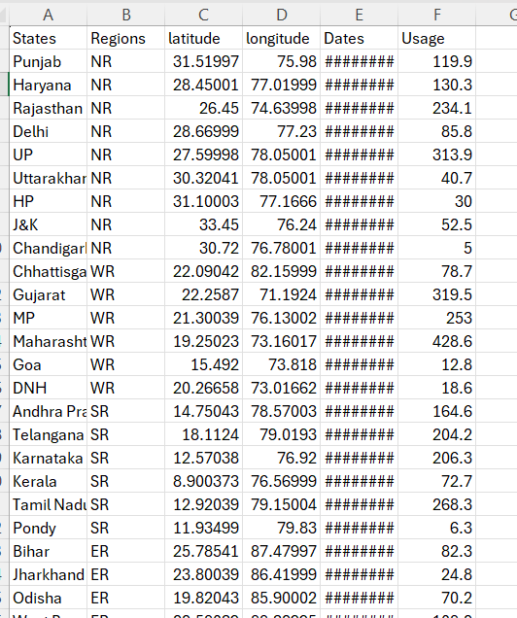  The dataset “Consumption.csv”was successfully imported into Tableau. It contains monthly and state-wise attributes such as region, state, month, year, and electricity consumption/power supplied (in million units)
- 2. | Data Preprocessing | Dataset cleaned and prepared before visualization. Missing values checked and handled (removing empty rows, imputing where appropriate). Duplicate records and inconsistent state names removed for accurate analysis.
3. | Utilization of Filters | State/Region Filter, Month Filter, Year Filter
4. | Calculation fields Used | Monthly Consumption Total, Average Consumption by Region, Year-over-Year Growth %, Peak Month Indicator
5. | Dashboard design | 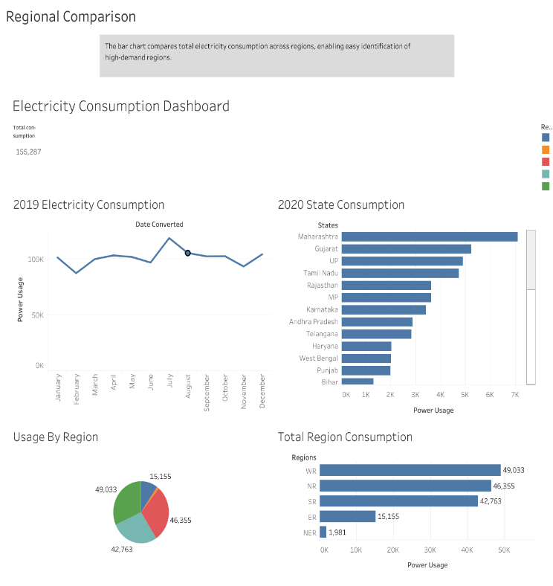  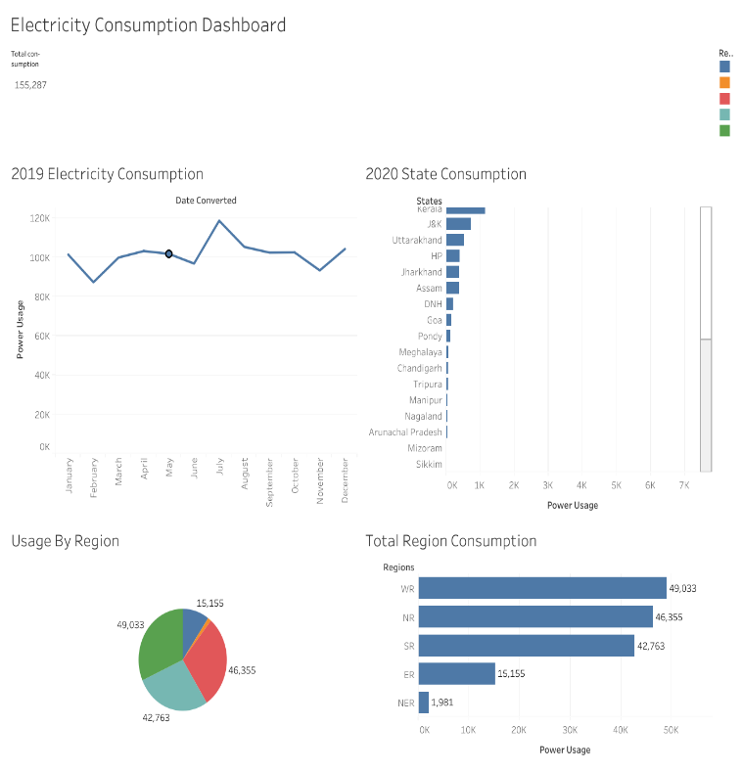  No. of Visualizations / Graphs — 8: Monthly Consumption Trend, State-wise Consumption Map, Top Consuming States, Consumption by Region, Seasonal Peak Analysis, Year-over-Year Growth, Peak vs. Off-Peak Comparison, Consumption Distribution by Month
6. | Story Design | No. of Visualizations / Graphs — 5: National Trend Overview, Regional Comparison, Seasonal Peaks, State Rankings, Year-over-Year Growth  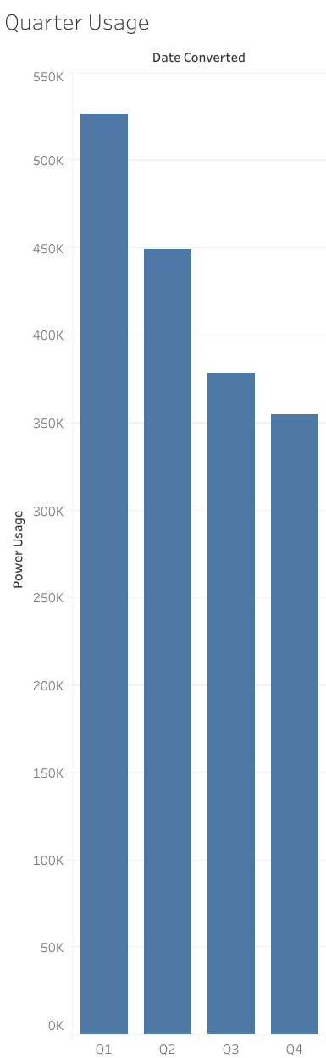  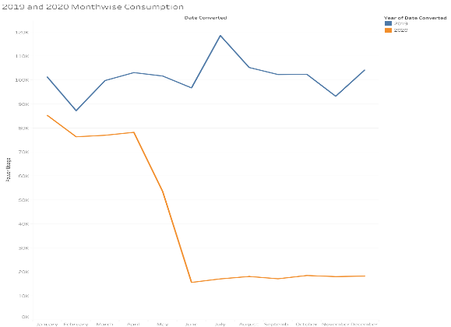  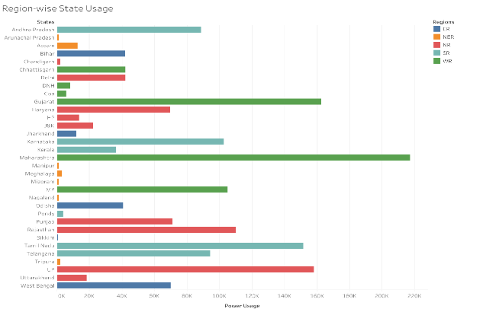

DASHBOARD:
